Installation of Xilinx Vitis is time consuming, you will need around 3 hours to start and complete the install, please plan ahead.

1. Goto: <https://www.xilinx.com/support/download.html>
2. Click on the Vitis (SW Developer) tab
3. Scroll down and click on the link:

AMD Unified Installer for FPGAs & Adaptive SoCs 2023.1: Windows Self Extracting Web Installer

1. Sign in or create an account and then click red Download
2. Open the self-extracting archive
   1. Read information on Welcome screen, click Next

* 1. Provide login information (same as used to download software). Select Download and Install Now radio button. Click Next.

* 1. Product to Install: Vitis - this will automatically install Vivado as well.

* 1. Select the following options:

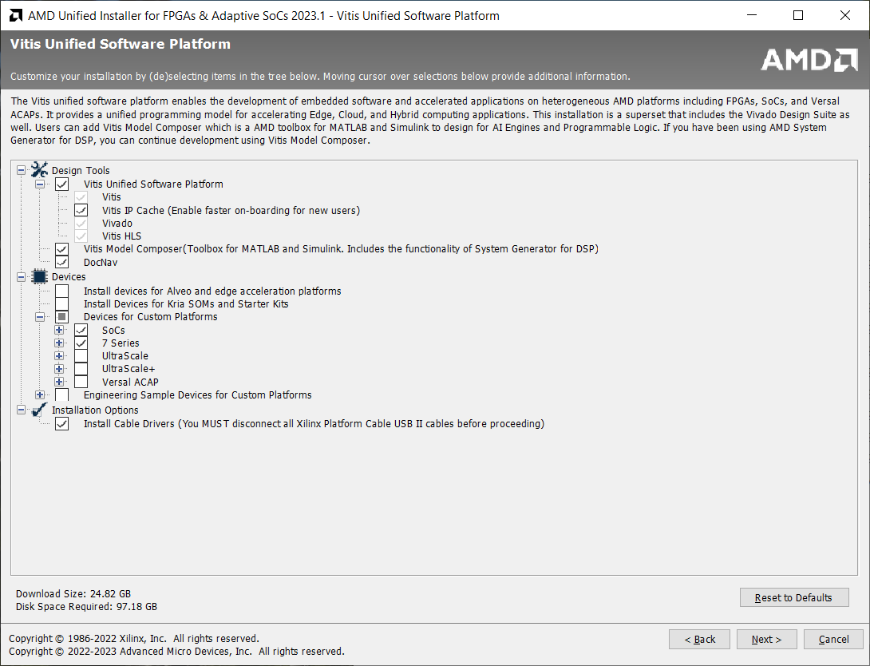

* 1. License Agreements: Scroll down and agree to all of them.

* 1. Put Xilinx in the root directory of your preferred (biggest) drive.

* 1. Click Install.

* 1. A few hours later…

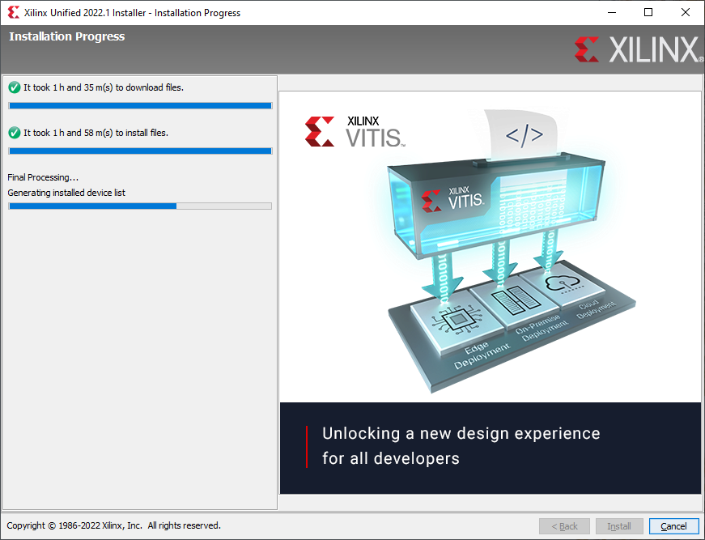

* 1. After this, you should be all set to go.